WEEK 4 TASK
Predictive Modeling and Optimization in Logistics Systems
Forecasting delivery time with Python machine learning
Prepared by: _shaik.Reehana___________________
Dataset: Hypothetical simulated shipment records (300 rows)

1. Executive Summary
This report demonstrates a reproducible predictive workflow using 300 simulated shipments. The target is delivery time in days. Linear Regression and Random Forest regression are compared on a held-out test set. The lower-MAE model is Linear Regression (MAE 0.675 days, RMSE 0.861 days, R² 0.992). Scores are illustrative only because the data are simulated.

2. Problem Definition
Logistics planners need delivery-time estimates to plan dispatches, communicate realistic delivery windows, allocate capacity, and identify shipments that may need intervention. This project predicts delivery time from distance, shipment volume, transport mode, weather, traffic, and estimated transport cost.

3. Dataset and Features
The hypothetical dataset has 300 records generated using NumPy with a fixed random seed. It is not real company data.
Feature | Type | Purpose
Shipment_ID | Identifier | Unique ID; excluded from training
Distance_km | Numeric | Route distance
Shipment_Volume_kg | Numeric | Shipment weight
Transport_Mode | Categorical | Road, Rail, Air
Weather | Categorical | Clear, Rain, Storm
Traffic_Level | Categorical | Low, Medium, High
Delivery_Time_days | Target | Value to predict
Transport_Cost_INR | Numeric | Estimated cost; used only if known at prediction time

4. Data Preparation and Modeling
Records were split into 80% training and 20% test data using a fixed random state. Numeric values are imputed with the median; categorical values are imputed with the most frequent category and one-hot encoded. Preprocessing is placed inside a pipeline to reduce leakage.

5. Model Selection
Linear Regression is a simple baseline that is relatively easy to interpret. Random Forest combines decision trees and can capture nonlinear patterns and interactions. Both are trained and tested on the same split for a fair comparison.

6. Evaluation Metrics and Results
MAE is the average absolute prediction error in days. RMSE penalizes larger errors more strongly. R² measures predictive fit relative to a mean-only baseline; it may be negative on test data.
Model | MAE (days) | RMSE (days) | R²
Linear Regression | 0.675 | 0.861 | 0.992
Random Forest | 1.172 | 1.541 | 0.973

7. Visualizations

Figure 1. Actual vs predicted
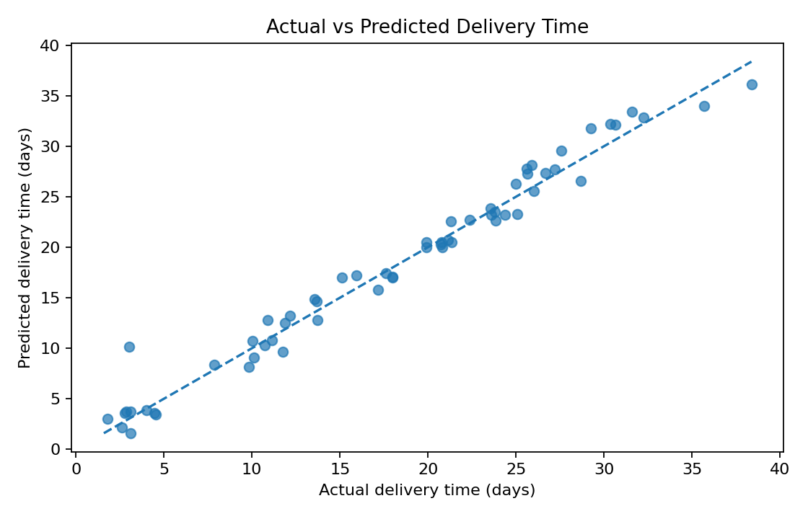
Points near the diagonal indicate more accurate predictions. Large deviations identify shipments where the model under- or over-estimates delivery time.

Figure 2. Prediction errors
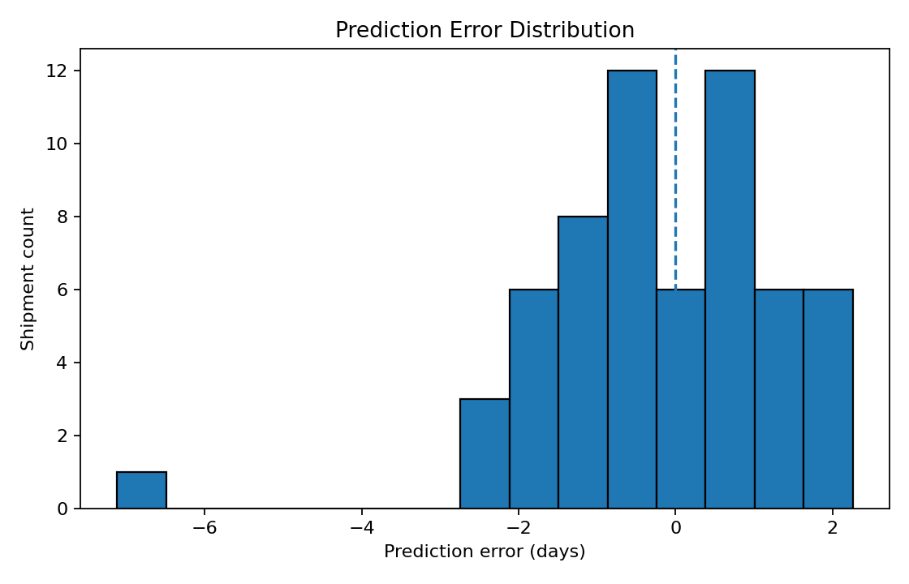
Errors around zero suggest limited average bias. Long tails or large errors indicate shipments that may need investigation.

Figure 3. Model comparison
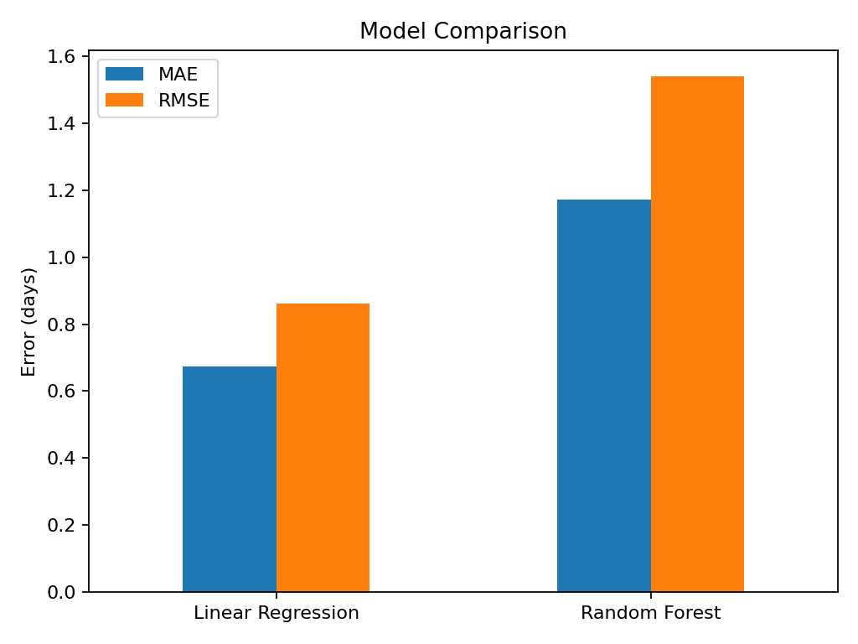
Lower MAE and RMSE indicate better test accuracy. Model choice should also consider interpretability and maintenance.

8. Validation and Tuning
This demonstration uses a held-out test set. A stronger workflow should use five-fold cross-validation on training data and tune Random Forest parameters such as n_estimators, max_depth, min_samples_leaf, and max_features with GridSearchCV or RandomizedSearchCV. Keep the test set untouched until final evaluation.

9. Optimization Recommendations
- Use predicted delivery times to set realistic delivery windows and flag shipments predicted to miss service targets.
- Review high-delay predictions and check route, traffic, weather, carrier capacity, and dispatch time.
- Compare transport modes on similar distances, weights, and service requirements rather than raw average cost alone.
- Consolidate compatible low-urgency shipments only when service commitments remain satisfied.
- Adjust route planning or dispatch timing to avoid predictable traffic peaks where practical.
- Monitor MAE, RMSE, on-time delivery, and cost weekly; retrain when patterns change.
Pilot any optimization before scaling it. Compare results with a baseline using cost, delivery time, on-time rate, and customer impact. Predictions support decisions but do not prove that an intervention will work.

10. Python Code Appendix
import pandas as pd
from sklearn.model_selection import train_test_split
from sklearn.compose import ColumnTransformer
from sklearn.preprocessing import OneHotEncoder
from sklearn.pipeline import Pipeline
from sklearn.impute import SimpleImputer
from sklearn.ensemble import RandomForestRegressor
from sklearn.linear_model import LinearRegression
from sklearn.metrics import mean_absolute_error, mean_squared_error, r2_score
df = pd.read_csv("week4_logistics_predictive_dataset.csv")
X = df.drop(columns=["Shipment_ID", "Delivery_Time_days"])
y = df["Delivery_Time_days"]
numeric = X.select_dtypes(exclude="object").columns
categorical = X.select_dtypes(include="object").columns
prep = ColumnTransformer([
("num", SimpleImputer(strategy="median"), numeric),
("cat", Pipeline([("imputer", SimpleImputer(strategy="most_frequent")),
("onehot", OneHotEncoder(handle_unknown="ignore"))]), categorical)
])
X_train, X_test, y_train, y_test = train_test_split(
X, y, test_size=0.20, random_state=21)
models = {"Linear Regression": LinearRegression(),
"Random Forest": RandomForestRegressor(n_estimators=120,
min_samples_leaf=2, random_state=21)}
for name, estimator in models.items():
model = Pipeline([("preprocess", prep), ("model", estimator)])
model.fit(X_train, y_train)
pred = model.predict(X_test)
print(name, "MAE", mean_absolute_error(y_test, pred),
"RMSE", mean_squared_error(y_test, pred)**0.5,
"R2", r2_score(y_test, pred))

11. Limitations
The dataset is simulated and simplified. Real delivery time also depends on origin and destination, carrier, warehouse handling, holidays, customs, service level, and route disruptions. Scores are not evidence of real-world performance. Validate on real historical data and monitor data leakage, bias, and model drift before deployment.

12. Conclusion
This project demonstrates defining a prediction target, preparing data, comparing a baseline and ensemble model, evaluating test performance, visualizing errors, and proposing optimization actions. The next step is to validate the workflow with real shipment records and a controlled operational pilot.

